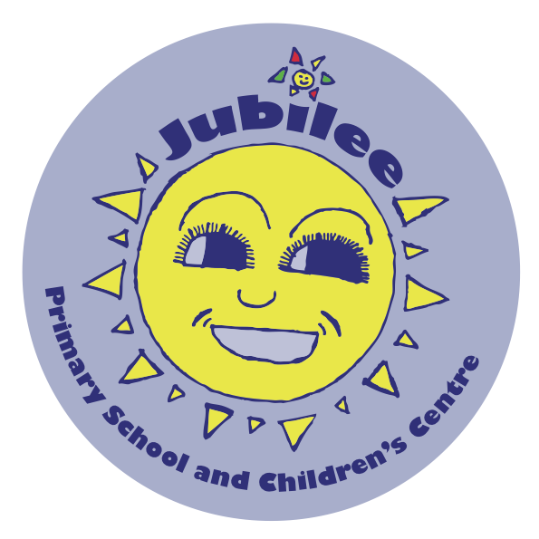
Music at Jubilee
Curriculum Intent
We are very proud of the high profile role music plays in the curriculum at Jubilee. We believe that music is a universal language that can bring groups and individuals together in society and as such, our ambitious curriculum is designed to give all learners (including those with SEND, EAL or those from disadvantaged backgrounds) equal opportunity to access the skills, knowledge and cultural capital they need to succeed in the subject. We want all our children from nursery through to year 6 to experience outstanding, high quality teaching that engages and inspires them to develop their love for music and their talent as musicians. We intend that through this high quality music provision, children increase their self-confidence, creativity and a sense of achievement. Performance plays a key role with a range of opportunities planned across the academic year both internally and externally. To deliver this ambitious curriculum, we work in partnership with both London Music Masters and Lambeth Music Service.

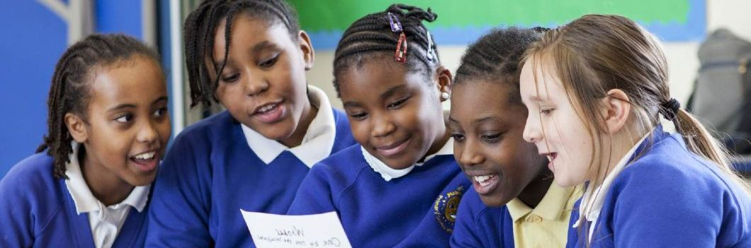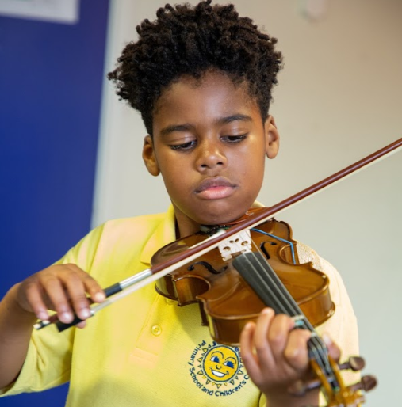
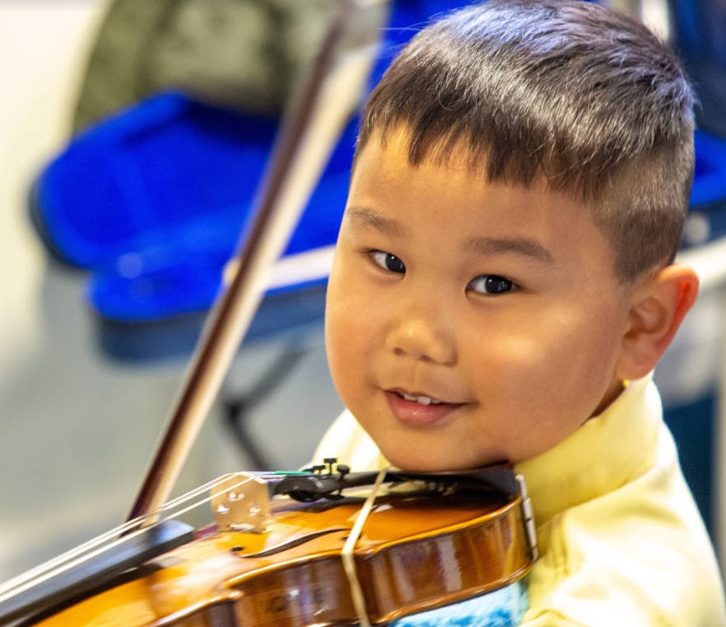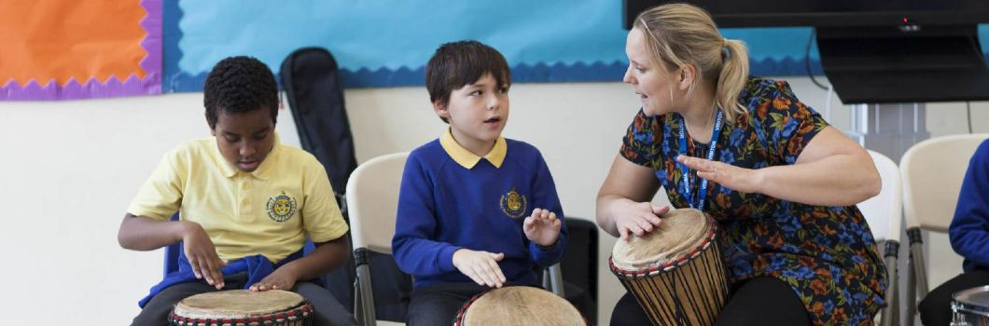

Progression across the school:
EYFS | Early Learning Goal  Children use what they have learnt about media and materials in original ways, thinking about uses and purposes. They represent their own ideas, thoughts and feelings through design and technology, art, music, dance, role play and stories.
 | Vocalising and Singing | Exploration of Sound and Pitch | Rhythmic Understanding and Development | Hearing and LIstening | Performance and Movement
Nursery | - FInd and develop their singing voices and become practiced at using different voice types.  - Develop a bank of songs that they can sing from memory including nursery rhymes.  - Sing known responses to a sung question.
Reception  (Taught via LMM Musicianship) | - Develop their use of different voice types when singing.  - Sing songs using the pentatonic scale,  - Sing together in several parts, in a canon or as call and response songs.  - Sing songs from around the world.  - Understand the importance of warming up their voices and being aware of their bodies when singing and making music. | - Recognise and play a range of pitched and unpitched instruments from around the world, encouraging fine motor skills and coordination.  - Influence the dynamic range of a song or piece to make it louder or softer.  - Understand and describe different sounds made by instruments, the body and voice.  - Use body solfa and recognise adapted visual notation for learnt patterns. | - Understand, manipulate and create simple pictorial rhythmic scores.  - Recognise and recreate the Suzuki Twinkle Rhythms.  - Understand the concept of simple phrasing.  - Understand the concept of pulse and maintain a pulse during spoken, sung and played musical activities.  - Manipulate a song or piece of music to make it faster or slower.  - Learn and recognise note values including ta, ti ti and sh.  - Learn to respond physically in time and with rhythm to played music.  - Improvise simple rhythms with voice, body or on instruments. | - Develop active listening skills and patience by listening to recorded and played pieces, or by listening to other children performing or playing.  - Recognise repeated sounds and sound patterns.  - Distinguish between high and low, loud and soft and fast and slow sounds.  - Be introduced to music from around the world.  - Learn to explore and share their ideas, thoughts, feelings and emotions on music.  - Listen to music performed by visiting musicians and ask questions.  - Listen to and match a pitch sung by someone else. | - Perform as a team, using eye contact and aurul clues to guide.  - Become confident in volunteering for a solo or suggesting a song/game/activity.  - Respond to music freely through dance or movement or through song and play.  - Increase their sense of leadership and responsibility and build confidence through taking the role of the leader in simple songs and games.
KS1 | National Curriculum:  Pupils should be taught to: use their voices expressively and creatively by singing songs and speaking chants and rhymes, play tuned and untuned instruments musically, listen with concentration and understanding to a range of high-quality live and recorded music, experiment with, create, select and combine sounds using the inter-related dimensions of music.
 | Playing and Singing | Music Terminology and Understanding | Rhythm and Pulse | Composing and Improvising | Listening and Reflection | Social, Moral, Cultural and Spiritual Links | Enrichment Opportunities
Year 1 and 2  (Taught via LMM violin lessons) | - Use singing as an essential tool to aid instrumental learning (singing to internalise and memorise pitch, rhythm, intonation, and melodic shape of pieces before they are played on an instrument.  - Understand and model healthy posture whilst handling the violin and be aware of the position of their body whilst playing.  - Develop a strong and healthy playing technique, improving FMS and coordination.  - Play using dynamics and phrasing.  - Play the A and D major scales.  - Practice right and left hand pizzicato.  - Learn to use the bow including up and down, retakes, string crossing and playing with articulation such as legato and staccato.  - Recognise good and bad intonation, and self correct their own intonation.  - Use string-specific extended techniques. | - Learn about and name the different parts of the violin, how to unpack it, how to handle it and how to care for it.  - Have a good understanding of the note names, not just the finger numbers.  - Develop an understanding of key signatures.  - Work on music theory and sight reading through exercises and activities.  - Become familiar with the following terminology: forte, piano, legato, staccato, pizzicato, crescendo, diminuendo, phrase.  - Understand where their strings are on a musical stave and read these notes. | - Understand the difference between pulse and rhythm.  - Recognise and play the following note values: ta (crotchet), ti-ti (quavers), tika-tika (semi-quavers), sh (crochet rest). They should recognise minims (ta-a) even if they can’t play them yet.  - Recognise and play the 5 Suzuki rhythms with long bows accurately as call and response.  - Learn how to start pieces on an upbeat.  - Understand syncopation and play syncopated rhythms. | - Improvise short phrases and rhythms on the violin in response to a peer or teacher.  - Start to understand the concept of harmony through playing and singing with others.  - Compose short passages on the violin | - Understand the wider orchestral and musical sound world.  - Actively listen to a range of music and be able to respond to questions about it related to musical elements and their own emotional and imaginative responses.  - Develop strong aural skills . | - Perform for the local community.  - Begin to identify as a musician.  - Take responsibility for the safety and care of their instrument.  - Take responsibility for their own practice and progress, understanding how with practice they can improve their skill and grow their confidence.  - Learn effectively with parents, teachers and peers in music lessons.  - Develop a respectful relationship with their instrumental teacher.  - Develop an understanding of music from around the world.  - Learn how to behave an act in lessons to make the most of their musical learning and to help their peers do the same. | - Weekly Singing Assembly (LMS) for all children.  - Infant Choir open to all children (LMS).  - Varied performance opportunities via LMM to peers, families and the public.  - Internal and external opportunities to listen to musicians play.  - Singing songs linked to topics and performing them as part of class assemblies.
KS2 | National Curriculum:  Pupils should be taught to: play and perform in solo and ensemble contexts, using their voices and playing musical instruments with increasing accuracy, fluency, control and expression, improvise and compose music for a range of purposes using the inter-related dimensions of music, listen with attention to detail and recall sounds with increasing aural memory, use and understand staff and other musical notations, appreciate and understand a wide range of high-quality live and recorded music drawn from different traditions and from great composers and musicians, develop an understanding of the history of music.
Lower KS2
Upper KS2

