Our topic for this term is:

***Temples, Tombs and Treasures***

We will:

* Explore what life was like in Ancient Egypt.
* Learn about Ancient Egyptian gods and beliefs about the afterlife.
* Understand the process of mummification.
* Discover the significance of pharaohs like Tutankhamun, and

what can be learnt

from their tombs.

* Learn to write using

Hieroglyphs.

**Year 3 Autumn 1 2019**

**3RJ and 3AM**

In Maths we will:

* Develop our understanding of place value of up to three-digit numbers.
* Identify, represent and estimate numbers in different ways.
* Compare and order numbers up to 1000.
* Count in multiples of 4, 8, 50 and 100.
* Add and subtract numbers mentally.
* Add and subtract numbers with up to three digits using formal written methods.
* Solve number and practical problems using number facts and place value.
* Develop our reasoning skills.

In Music we will:

* Learn to play the recorder, glockenspiel and Djembe drums.
* Learn about beat, rhythm and tempo.

****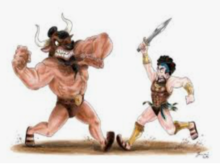******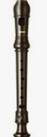**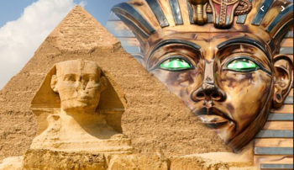****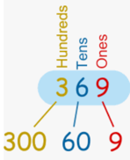

In Computing we will:

* Learn about how

we can stay safe

and make good choices online.

* Use search engines and

communication tools.

In PE we will:

* Begin our swimming lessons at Brixton Rec.
* Learn co-ordination, balance and ball-control skills

in football.

In RE we will:

* Learn about Islam.
* Develop our understanding of the worship and festivals of other faiths.

In Science we will learn about ***Light***.

We will:

* Learn about light and understand darkness as the absence of light.
* Investigate how shadows are made and changed.
* Discover how light reflects and different reflective surfaces.
* Explore how mirrors work.
* Plan a simple enquiry then record

and present our findings.

In English we will learn about ***Myths and Legends*** including Theseus and the Minotaur.

We will:

* Read myths and legends from different countries and cultures and make links.
* Consider characters’ emotions.
* Use interesting adjectives.
* Write a diary entry in the first person.
* Write an advertisement.
* Learn about direct and

indirect speech, and

begin to use inverted

commas.

* Write a play script.